Trading and Market Data Management

FNCE 668

Term Project:

Impact of Oil Price Fluctuations on Energy Sector’s Stock Returns

H M Jahid Hassan

30215295

**Introduction**

This project analyzes the impact of oil price fluctuations on the stock returns of oil-related companies, non-oil companies, and the broader market, represented by the SPX index. By examining the sensitivity of these sectors to oil price changes, the study aims to uncover patterns in volatility and returns that may inform investment strategies. Using historical data and regression analysis, we assess the degree of oil price dependency across different sectors and provide insights into their respective risk profiles.

**Objective**

This analysis aims to examine the relationship between oil price fluctuations and the stock returns of companies in the energy sector (oil companies) compared to those outside it (non-oil companies) and the broader market, represented by the S&P 500 Index (SPX). Understanding this relationship is essential, as oil prices significantly impact the global economy, affecting industries and stock markets in various ways. By analyzing this relationship, we can provide insights that help investors and financial professionals manage sector-based exposure to oil price risk.

**Background**

Oil prices are a critical economic factor, with broad implications for industries and financial markets. Energy companies, whose revenues are heavily tied to oil, tend to show greater sensitivity to oil price movements. Conversely, companies outside the energy sector, such as those in technology or consumer goods, are less directly impacted by changes in oil prices, often experiencing only indirect effects. The broader market, represented by indices like the SPX, includes a diverse set of industries and may respond differently to oil price fluctuations.

**Hypothesis**

Hypothesis

We hypothesize that stock returns of oil companies will be significantly more sensitive to changes in oil prices than those of non-oil companies and the overall market (SPX Index). Specifically, we expect:

* Higher sensitivity of oil company stock returns to oil price movements, as these companies' profits are directly influenced by oil prices.
* Lower sensitivity of non-oil company stock returns, as these companies face only indirect effects from changes in energy costs.
* Minimal effect on the SPX Index, as its broad sector composition dilutes the direct impact of oil price fluctuations on the overall market.

**Data Collection and Preparation**

**Data Sources**

Data for this analysis was collected from Bloomberg, including:

* Oil prices: Represented by the CL1 Comdty (Crude Oil futures contract).
* Stock prices of oil companies: A set of major energy sector companies.
* Stock prices of non-oil companies: A diverse selection of companies outside the energy sector.
* S&P 500 Index (SPX): Used as a benchmark for the broader market.

All the price data are kept in an excel file (File Name: Price Data.xlsx) from the Bloomberg terminal.

**Time Period**

The analysis covers a 3-year period from October 2021 to October 2024, selected to capture meaningful trends and fluctuations in oil prices.

**Companies Analyzed**

* Oil Companies: The analysis includes the following major energy companies:

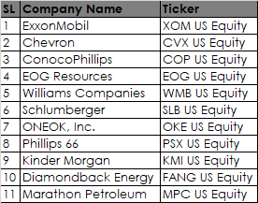

* Non-Oil Companies: To provide contrast, the following non-energy companies were included:

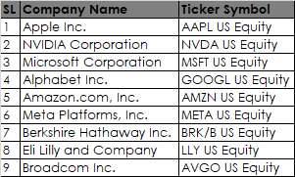

**Data Cleaning and Preparation**

To ensure consistency and accuracy in analysis:

* Handling Missing Data: Any missing values in stock prices or oil prices were removed to maintain completeness.
* Aligning Dates: The data was aligned by date to ensure all indices and oil prices could be compared directly daily.

### ****Methodology****

#### ****Data Preparation and Daily Returns Calculation****

* **Data Loading and Cleaning: The dataset includes daily price data for oil prices (CL1 Comdty), oil companies, non-oil companies, and the SPX index. Missing values were removed, and dates were aligned to ensure consistent comparisons across all data points.**
* **Daily Returns Calculation: Daily returns were calculated as the percentage change in price from one day to the next for each dataset. These returns are stored as oil_stocks_returns, non_oil_stocks_returns, oil_prices_returns, and spx_returns.**

**Formula for Daily Returns**:

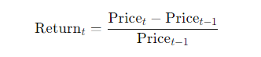

#### ****Equal-Weight Index Construction****

* **Oil Company Index (oil_index): This index was created by averaging the daily returns across all oil companies listed in oil_stocks_columns.**
* **Non-Oil Company Index (non_oil_index): This index was created by averaging the daily returns across all non-oil companies listed in non_oil_stocks_columns.**

#### These equal-weight indices provide a single daily return metric representing each group, allowing straightforward comparison with oil price returns.

#### ****Regression Analysis****

* **Objective: To measure the sensitivity of oil and non-oil company indices to oil price fluctuations, we performed Ordinary Least Squares (OLS) regression using Oil Price Returns (oil_prices_returns['CL1 Comdty']) as the independent variable.**
* **Function (run_regression): This function fits an OLS model and returns the regression results. The dependent variables in each regression are the daily returns of oil_index, non_oil_index, and spx_returns.**

**Regression Model**:



Where:

* Return I,t: Daily return of oil_index, non_oil_index, or spx_returns.
* Oil Price Return t ​: Oil price returns (oil_prices_returns['CL1 Comdty']).
* β: Sensitivity coefficient, indicating how much stock returns change in response to a 1% change in oil prices.

#### ****Volatility Analysis****

* 30-Day Rolling Volatility: A 30-day rolling standard deviation was calculated for oil_index, non_oil_index, and oil_prices_returns['CL1 Comdty'] to examine how each group's volatility changes over time.

#### ****Cumulative Returns Analysis****

* **Cumulative returns** for oil_index, non_oil_index, and oil_prices_returns['CL1 Comdty'] were calculated to illustrate the long-term growth trends of each index relative to oil prices. This metric helps visualize differences in performance across oil companies, non-oil companies, and oil prices over time.

**Regression Analysis**

We conduct a regression analysis to examine the relationship between oil price fluctuations and the returns of the oil company index, non-oil company index, and SPX index. The Ordinary Least Squares (OLS) regression results provide insights into the sensitivity of each index to oil price movements. Below, we interpret the key findings from each regression table.

**Oil Company Index Regression**

**R-Squared:** The R-squared value of 0.794 indicates that approximately 79.4% of the variation in the oil company index returns is explained by changes in oil prices. This high R-squared value suggests a strong relationship between oil price fluctuations and oil company returns.

**Coefficient (CL1 Comdty):** The coefficient for oil prices (CL1 Comdty) is 0.8290, with a p-value < 0.001, indicating a statistically significant positive relationship. For every 1% increase in oil prices, the oil company index returns are expected to increase by approximately 0.83%. This result aligns with the understanding that oil company performance is highly sensitive to oil price changes.

**Constant:** The intercept is close to zero and not statistically significant (p-value = 0.993), suggesting that without oil price movement, there is no significant return for the oil company index.

**Interpretation:** The oil company index shows a strong positive correlation with oil prices, implying that oil price increases drive returns for oil-related stocks. This confirms the dependency of oil companies on oil prices.

**Non-Oil Company Index Regression**

**R-Squared:** The R-squared value of 0.022 indicates that only about 2.2% of the variation in non-oil company index returns is explained by oil price changes. This low R-squared value suggests a weak relationship between oil prices and non-oil company returns.

**Coefficient (CL1 Comdty):** The coefficient for oil prices is 0.1384 with a p-value of 0.000, which is statistically significant but has a smaller impact compared to the oil company index. A 1% increase in oil prices results in a 0.14% increase in non-oil company index returns. While the relationship is statistically significant, the low coefficient value indicates that non-oil companies are less affected by oil price changes.

**Constant:** The intercept is also close to zero but has a p-value of 0.063, which is marginally significant.

**Interpretation:** The non-oil company index shows a weak correlation with oil prices, meaning that these companies are relatively insulated from oil price volatility. This result suggests that non-oil companies have diversified operations that mitigate their exposure to oil price changes.

**SPX Index Regression**

**R-Squared:** The R-squared value of 0.100 indicates that 10% of the variation in SPX index returns is explained by oil price movements, which is relatively low. This suggests that oil prices have a limited effect on the broader market index.

**Coefficient (CL1 Comdty):** The coefficient for oil prices is 0.2006 with a p-value < 0.001, indicating a statistically significant relationship. However, the magnitude of the coefficient is small, implying that a 1% increase in oil prices leads to only a 0.2% increase in SPX index returns.

**Constant:** The intercept is not statistically significant (p-value = 0.553), indicating no significant baseline return for the SPX index in the absence of oil price movement.

**Interpretation:** The SPX index shows a low sensitivity to oil price changes, as indicated by the small coefficient and low R-squared value. This suggests that while oil prices have some effect on the overall market, their influence is minimal compared to factors affecting the SPX index.

**Summary**

The regression analysis reveals a clear pattern: the oil company index is highly responsive to oil price fluctuations, the non-oil company index is only weakly correlated with oil prices, and the SPX index has minimal sensitivity to oil prices. This analysis underscores the sector-specific impact of oil prices, with oil-related stocks being more directly influenced by price changes in the oil market.

**Visualizations and Key Figures**

This section presents visual analyses to support the findings from the regression results, illustrating how oil price fluctuations impact the volatility and returns of oil-related companies, non-oil companies, and the broader market.

**30-Day Rolling Volatility Plot**

Purpose: To observe the volatility patterns of oil and non-oil companies over time, relative to oil price volatility. This helps identify periods when oil price fluctuations are particularly impactful on sector-specific volatility.

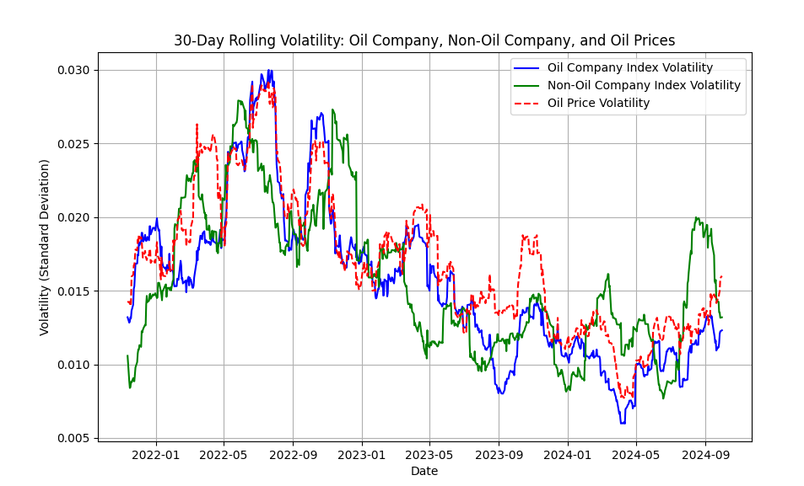

Figure 1: 30-Day Rolling Volatility of Oil Company Index, Non-Oil Company Index, and Oil Prices

**Description:** The plot demonstrates that the oil company index volatility (blue line) closely follows oil price volatility (red dashed line). Peaks in oil price volatility correspond with similar peaks in the oil company index volatility, indicating a strong sensitivity to oil price changes. Conversely, non-oil company volatility (green line) remains relatively stable, suggesting that these companies are less affected by oil price shocks.

**Cumulative Returns Plot**

**Purpose:** To compare cumulative returns for oil companies, non-oil companies, and oil prices, highlighting performance trends over the analysis period. This illustrates how returns differ between sectors and provides insight into long-term growth or declines based on oil price movement.

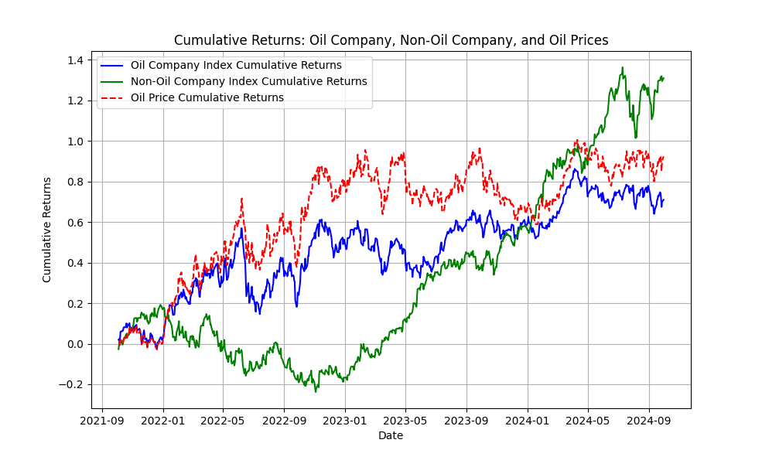

Figure 2: Cumulative Returns of Oil Company Index, Non-Oil Company Index, and Oil Prices

**Description:** The cumulative returns chart shows that the oil company index (blue line) tends to rise and fall in line with oil prices (red dashed line), reflecting the dependency of oil-related companies on oil price performance. The non-oil company index (green line), however, shows more stable and consistent growth, independent of oil price trends. This pattern supports the regression analysis findings, suggesting that non-oil companies are relatively insulated from oil price volatility.

**Analysis Summary**

The visualizations underscore key findings from the regression analysis:

* High Volatility for Oil Companies: The rolling volatility chart shows that oil companies experience substantial volatility that aligns with oil price fluctuations, indicating higher risk exposure to oil price shocks.
* Cumulative Returns Dependence: The cumulative returns chart further highlights that oil companies' performance is closely tied to oil prices, while non-oil companies exhibit stable growth, relatively unaffected by oil market trends.

These figures provide a clear visualization of the relationship between oil price fluctuations and different sectors, supporting the regression results and giving a visual representation of the oil dependency of various industries.

**Conclusion**

This analysis examined the impact of oil price fluctuations on the stock returns of oil companies, non-oil companies, and the broader SPX index. The findings reveal a strong correlation between oil prices and oil company returns, indicating that oil-related stocks are highly sensitive to changes in the oil market. In contrast, non-oil companies show only a weak relationship with oil prices, highlighting their resilience to oil price volatility, likely due to diversified operations. The SPX index exhibits minimal sensitivity to oil price movements, suggesting that the broader market is relatively insulated from fluctuations in the oil sector.

Overall, this analysis underscores the sector-specific nature of oil price risk, with oil companies facing greater volatility and potential for returns driven by oil price trends, while non-oil companies provide a more stable investment option. These insights can help investors make informed decisions based on their risk tolerance and sector exposure preferences.